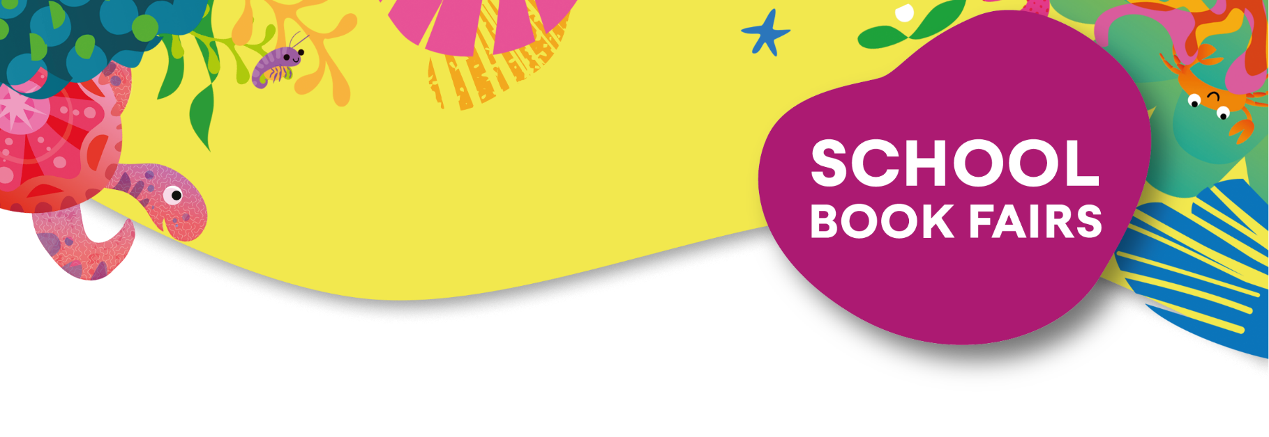

Dear Parent/Guardian,

To promote reading for pleasure and to encourage our pupils to read more broadly, we are having a School Book Fair on Tuesday 19th November 2024 in the Ballet Studio, the fair will open to pupils and parents to browse after school.

The book fair is being organised in conjunction with our local Usborne Schools Partner, Katie Slingerland, and every book purchased will go towards brand new **FREE** books for our school.

Usborne will donate **60%** of the total book fair sales value raised in **FREE BOOKS** to the school. So, for every **£600** of books purchased, we will earn **£360** in FREE Usborne books for our school!

Books can be purchased on the day of the book fair and paid for by cash or debit/credit card. Alternatively, you can browse the full range online here: [Barrow Hills School Book Fair](https://usborne.com/gb/uevent?event=9757c3c9174d3dff82965488c872ca64)

or here: 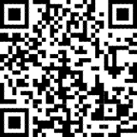

You can either pay £3.50 to have your order shipped to an address of your choice or opt for free delivery and your books will be delivered to your child at school.

We look forward to having lots more books for your child to read, share and enjoy.

For more information and for tailored book recommendations for your child, please contact: Katie Slingerland – [katiebooklady@gmail.com](mailto:katiebooklady@gmail.com) or 07933 728936.A yellow and purple background
